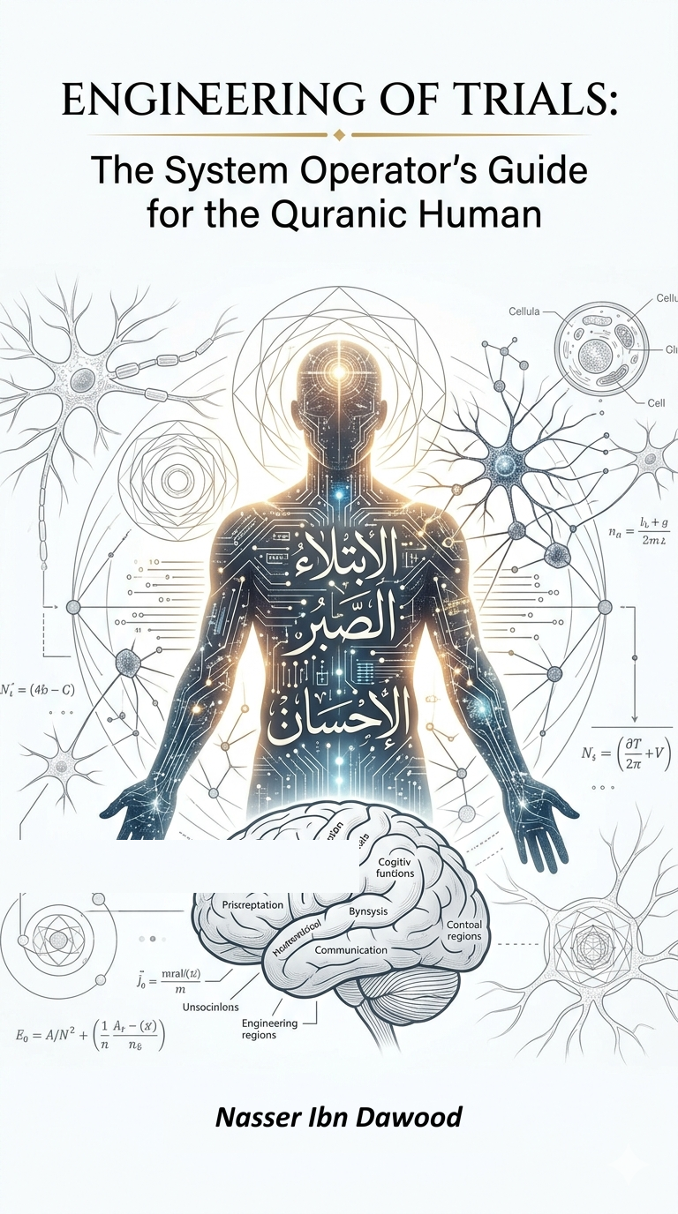
(Condensed Adaptation)
Engineering of Trials
The System Operator’s Guide for the Quranic Human

I. The Global Knowledge Manifesto
Knowledge is a universal right. The author firmly believes that wisdom should not be locked behind paywalls or language barriers.
- Global Access Policy: All books in this library are available for free in multiple digital formats (PDF, HTML, DOCX, TXT).
- The Digital Library: As of early 2026, the collection hosts 68 volumes (34 in Arabic and 34 in English), fully optimized for AI-assisted research and digital archiving.
- Official Platforms:
  - Main Website: nasserhabitat.github.io/nasser-books/
  - GitHub: nasserhabitat/nasser-books

- II. Translator’s Note: The Bridge of Meaning
This English edition is a condensed conceptual adaptation. It is not a word-for-word translation, but rather an "extraction of essence." It presents the core philosophical framework in accessible English, omitting the exhaustive linguistic debates and classical references found in the original Arabic text.
For the academic researcher: The original Arabic version remains the primary source for comprehensive linguistic analysis, detailed exegesis (Tafsir), and the complete bibliography.

1. The Paradigm Shift: From Passive Faith to Systemic Operation
Most contemporary religious interpretations suffer from "Fragmentation." Concepts like Worship, Faith, and Patience are treated as isolated moral instructions. This book proposes a radical shift: viewing the Quran as a Functional Operating System.
In this framework:
- Worship is not a ritual; it is a Life Management System.
- Faith is not mere belief; it is a Cognitive Architecture.
- Trials are not punishments; they are Structural Stress Tests.

2. The Engineering of Trials (The Structural Transformer)
The central theme of this work is the "Trial" (Ibtila’), redefined as the Operating Environment of the human experience.
2.1. Al-Fitna: The Smelting Process
Fitna is the "Stress Test." Just as metals are smelted to separate impurities, Fitna creates a high-pressure environment to reveal hidden flaws in the human ego and psychological structure.
2.2. Al-Bala’: The Pressure Vector
Bala’ is the input of energy—whether positive (blessings) or negative (hardships). It is designed to trigger a response from the "System." How the system processes this pressure determines its level of refinement.
2.3. Tamhees: Structural Purification
The goal of the trial is Tamhees (Refinement). It is the technical process of removing "cognitive noise" and ego-driven impurities, leaving behind a "Pure Human Alloy" capable of handling the highest levels of responsibility.

3. The Operating Systems (Functional Tools)
To navigate the environment of trials, the Creator has provided built-in "Operating Protocols":
- Salat (System Reset): A periodic calibration. It resets the human’s "Directional Antenna" (The Qibla) toward the Source, clearing the system’s cache of the day’s psychological residues.
- The Breath (Input Rhythm): Breath is the physical carrier of the "Divine Command." Conscious breathing is the rhythmic input of meaning and energy into the biological hardware.
- Water (The Information Carrier): Water is the medium that distributes information and life. It serves as the solvent for refinement, washing away the residues of trials both physically and spiritually.

4. The Command Center: The Throne of Management
The human brain—with its eight functional regions—acts as the "Carriers of the Throne." This is the neural command center where all trials are processed.
- The Soul (Nafs): The raw, reactive material of the human.
- The Human (Insan): The engineered, stable, and "Upgraded" version of the soul.
- The System Operator: The "Quranic Human" is the authorized operator of this system. By understanding the "Codes" of the Quran, the operator gains the Sultan (Authority/Power) to transcend the "Spheres of Heavens and Earth."

5. The Final Output: The Great Fortune
The ultimate result of this engineering process is Al-Hath al-Atheem (The Great Fortune). In this framework, "Fortune" is not a random occurrence or luck; it is a Merit-Based Systemic Output.
It is the state of Harmonic Resonance, where the human consciousness is perfectly aligned with the Universal Laws (Sunan). This is the transition from a life of chaos and reaction to a life of mastery, peace, and eternal functional success.

[End of Condensed Edition]
For further exploration, visit nasserhabitat.github.io/nasser-books/

